TMApps Launcher KB Library
  - User guides setup and troubleshooting
Release 1.15.1 | 23 October 2026 | DaddyTylerXO
Use this library to install the launcher, manage your applications, find settings, and report problems. Each article has a stable KB number that you can type into launcher Help or settings search. Shared TMApps sign-in is prepared for deployment and requires backend configuration before activation. App support varies by operating system.
The TMApps Master KB link is pending publication on the main branch when this guide is prepared. This app library remains available offline. Provider sign-in, app downloads, API checks and support links require an internet connection.
Use the orange KB buttons to jump to an article, then Back to index to return. In Microsoft Word, hold Ctrl while clicking a link if required by your settings. Screenshots illustrate the launcher controls; versions and available apps may change.

Article index
KB number | Subject
Launcher‑KB1 | Install the launcher
Launcher‑KB2 | Install and update applications
Launcher‑KB3 | Profile and social account suggestions
Launcher‑KB4 | TMApps sign in and app access
Launcher‑KB5 | Choose your appearance
Launcher‑KB6 | Reduce resource usage
Launcher‑KB7 | Review and submit a crash report
Launcher‑KB8 | Get help and request changes
Launcher‑KB9 | App details and galleries
Launcher‑KB10 | Privacy and local data
Launcher‑KB11 | Search settings and knowledge articles
Launcher‑KB12 | Troubleshoot platform compatibility
Launcher‑KB13 | Coming soon applications
Launcher‑KB14 | Install Libraries and Finance
Launcher‑KB15 | Spotify playback and browser streaming
Launcher‑KB16 | Autofill profiles across TMA apps
Launcher‑KB17 | Check service status

Launcher KB1 Install the launcher
Back to index
Download the build for your OS and CPU. Windows uses Setup.exe and offers install location, startup and shortcuts. On macOS drag the app from its DMG to Applications.
On Linux make the AppImage executable; if FUSE is unavailable use --appimage-extract-and-run. Launcher OS support is separate from the apps in its library. See Launcher‑KB2 and Launcher‑KB12 .
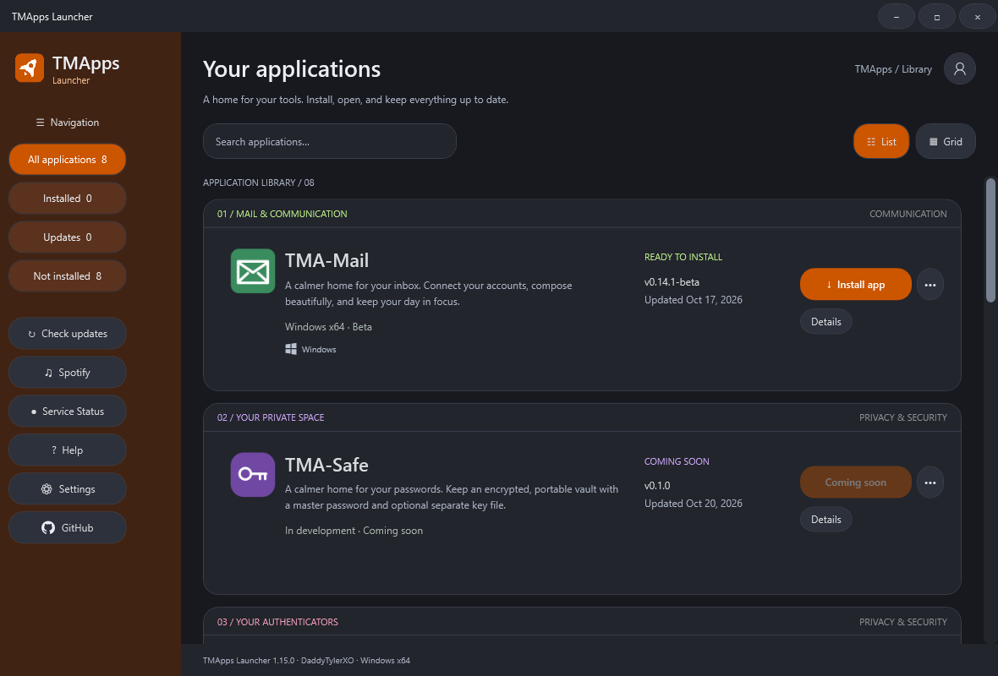
The application library after opening the launcher. Available apps depend on your operating system.

Launcher KB2 Install and update applications
Back to index
Use Install or Update in the library. Select an empty app folder and choose startup and desktop options. Updates check hashes before replacing files.
Allow a running app to close before updating; force close is a separate choice. Uninstall can preserve or delete standard local data. External work folders are preserved.
See Launcher‑KB1 and Launcher‑KB10 . See Launcher‑KB13 for coming-soon apps.
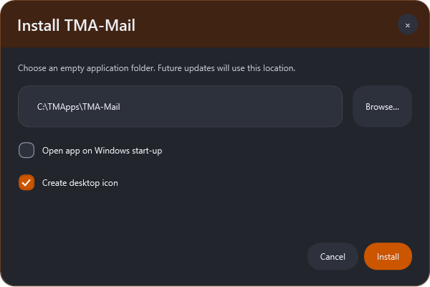
App installation offers a destination folder, startup and desktop shortcut options on Windows.

Launcher KB3 Profile and social account suggestions
Back to index
Your optional profile stays on this device. Enter your name and one email address, then choose + Add email address for additional addresses, up to 20. Remove deletes a row; the first saved email is your primary suggestion.
Choose profile photo accepts a PNG or JPEG smaller than 4 MB, crops it to a square and stores a small local PNG when you save. Remove photo restores your initial. Cancel discards unsaved profile and photo edits.
Photos are not shared with providers or other apps. Optional social accounts hold usernames or public HTTPS profile URLs, never passwords or tokens. Shared profile suggestions do not sign in to provider accounts.
Control overall, Mail and future social sharing separately. See Launcher‑KB4 , Launcher‑KB10 and Launcher‑KB16 .
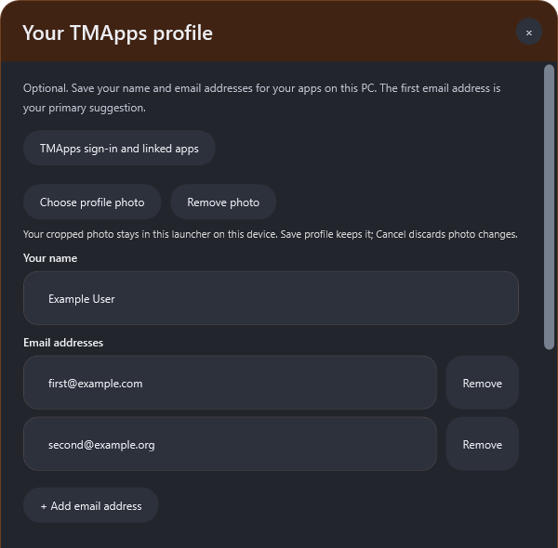
The optional profile shares suggestions with Mail. Provider authentication is still completed in the app.

Launcher KB4 TMApps sign in and app access
Back to index
TMApps email-code sign-in requires the operator to deploy and configure the prepared sign-in service. Once enabled, sign in once and select which supported apps may request a TMApps session. This does not transfer social-network or mailbox passwords.
Apps must implement the session handoff before they can reuse sign-in. Revoking app access stops future handoffs. See Launcher‑KB3 and Launcher‑KB10 .

Launcher KB5 Choose your appearance
Back to index
In Settings, choose the Appearance tab. Pick Orange, Grey or Black, move navigation to Left, Right, Top or Bottom, choose List or Grid, and toggle Compact Navigation Bar. Save keeps changes; Cancel restores the previous appearance.
The title bar and scrollbars use the dark theme. Drag the title bar to move the window, double-click to maximize or restore, and use its window buttons to minimize or close. In list view, Details sits below the Open, Install or Update action.
Spotify playback modes and account opens the music settings. See Launcher‑KB9 and Launcher‑KB15 .
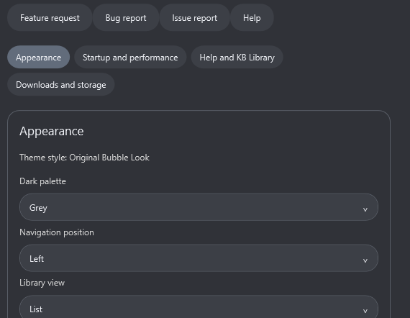
Appearance controls with the Grey palette selected. Save keeps your chosen layout and colours.

Launcher KB6 Reduce resource usage
Back to index
Close-to-tray keeps the launcher in memory; use Quit to release it. Startup launch affects boot time. Startup update checks use network and some CPU briefly.
App videos use network, RAM, decoding CPU and GPU while playing; playback starts only when requested. Screenshots load only in app details. Close details to release media.
Functional and resource checks run in the release workflow. See Launcher‑KB5 and Launcher‑KB9 . Optional Spotify controls refresh every 15 seconds only while their music window is open and visible.
Closing it stops refresh work. Browser streaming uses the browser's CPU, RAM and network; Connect playback uses the selected Spotify device. See Launcher‑KB15 .
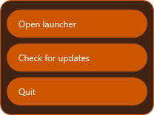
Choose Quit from the tray menu to release launcher memory.

Launcher KB7 Review and submit a crash report
Back to index
The launcher prepares a local report with app version, OS, architecture and redacted error details. Review the full draft before choosing Upload to GitHub Issues. That opens the GitHub report form; you sign in and submit it there.
Nothing is sent automatically. Remove anything you do not want public. Reports omit credentials and your saved profile.
See Launcher‑KB8 and Launcher‑KB10 .

Launcher KB8 Get help and request changes
Back to index
Use Help to search this library, request a feature, report a reproducible bug, or report another issue. Each action opens its matching GitHub form. Choose the affected app and describe expected versus actual behaviour.
Do not include passwords, keys, mail content or private project files. See Launcher‑KB7 .
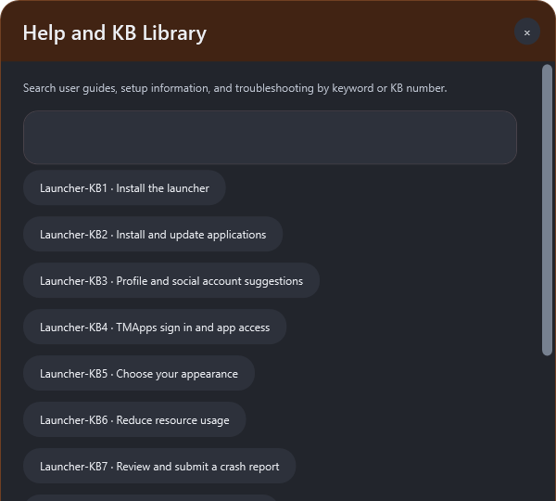
Help provides the KB Library and actions for GitHub support forms.

Launcher KB9 App details and galleries
Back to index
Click an app name or Details to open its showcase. The header shows the app icon, description, version and update date. Open, Install or Update is available when the app supports your operating system; GitHub opens its source branch.
Published screenshots appear in a gallery with Previous, Next and thumbnail buttons, up to ten per app. A showcase video appears only when published and plays only when requested. Missing media stays unpublished.
Feature cards and Latest release show available app information; preview limitations remain in the release notes. Close the screen to release media resources. In List view Details is below the main app action.
See Launcher‑KB2 and Launcher‑KB6 .
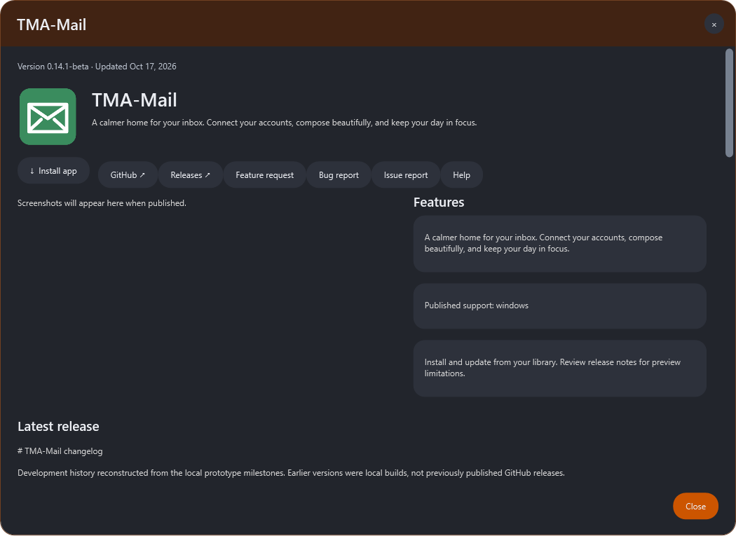
App details show version information and release notes. Media slots remain unpublished until assets are supplied.

Launcher KB10 Privacy and local data
Back to index
Profile suggestions and app preferences are local to your OS user. Sign-in sessions, when configured, are protected with the OS credential facility; Linux without a secure keyring keeps sessions in memory only. GitHub reports become public only after you submit them.
Uninstall choices apply to the selected app; external projects are kept. See Launcher‑KB3 and Launcher‑KB7 .
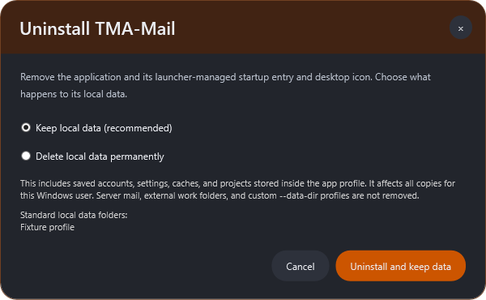
The uninstall dialog lets you choose whether the selected app keeps its standard local data.

Launcher KB11 Search settings and knowledge articles
Back to index
Settings groups options into Appearance, Startup and performance, Help and KB Library, and Downloads and storage on Windows. Choose a section button to focus its controls. Search settings searches all sections by keyword.
Help has a dedicated Search KB Library field on Windows; Open KB Library and support opens the searchable library on macOS and Linux. Include KB articles in settings search can be disabled without removing Help. Enter a stable reference such as Launcher‑KB6 to find the matching guide.
See Launcher‑KB5 , Launcher‑KB6 and Launcher‑KB8 .
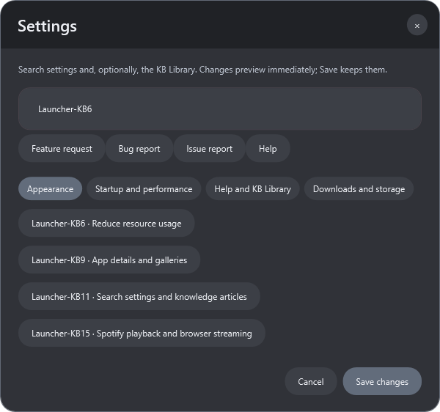
Search by keywords or a KB number to find relevant knowledge articles.

Launcher KB12 Troubleshoot platform compatibility
Back to index
Choose x64 for Intel/AMD and arm64 for Apple Silicon or ARM Linux. Do not install a Windows EXE on macOS or Linux. Only published matching app packages can be installed. macOS packages currently use ad-hoc signing and are not notarized; OS approval may be required.
Linux tray support depends on the desktop. See Launcher‑KB1 and Launcher‑KB7 .

Launcher KB13 Coming soon applications
Back to index
Coming soon means no installable package has been published. A source branch or app icon alone does not mean an app is ready to install. Check for updates to refresh verified availability.
The OS badges show the platforms with actual published builds; a Windows app cannot be installed by the macOS or Linux launcher. Libraries and Finance have published Windows development packages and their app icons. Their feature sets are incomplete; review Details and release notes before installing.
SocialsManager stays immediately before Agent Office, which is always last and moves down when apps are added. Older launchers may need to update and restart before they can read an expanded app catalog. See Launcher‑KB2 and Launcher‑KB14 .

Launcher KB14 Install Libraries and Finance
Back to index
Choose Check updates to load the published app catalog. A GitHub source push alone is not an installable app update: a tested package, version and checksum must also be published. Libraries 0.2.0-dev.1 is an unsigned Windows development preview with offline document, checklist, spreadsheet, slide and PDF editors.
Advanced format fidelity and performance work remain pending. The packaged editor test used about 896 MiB after exercising all editors; close unused editors and quit the app when finished. Export backups before updating from Libraries 0.1.0.
The preview uses a separate roaming TMA-Libraries/library-v2 profile; legacy local TMApps/TMA-Libraries records remain untouched. Import a schema-1 workspace export inside Libraries to migrate; close the legacy app first. Launcher 1.14.2 only deletes the legacy Libraries data location when Delete local data is chosen; the new preview profile is retained and must be managed separately.
Finance provides budgets, savings and a manual investment workspace. Both apps store records without app-level encryption. No provider key is entered in the launcher.
No macOS or Linux package is advertised until matching verification is complete. See Launcher‑KB2 , Launcher‑KB10 and Launcher‑KB13 .
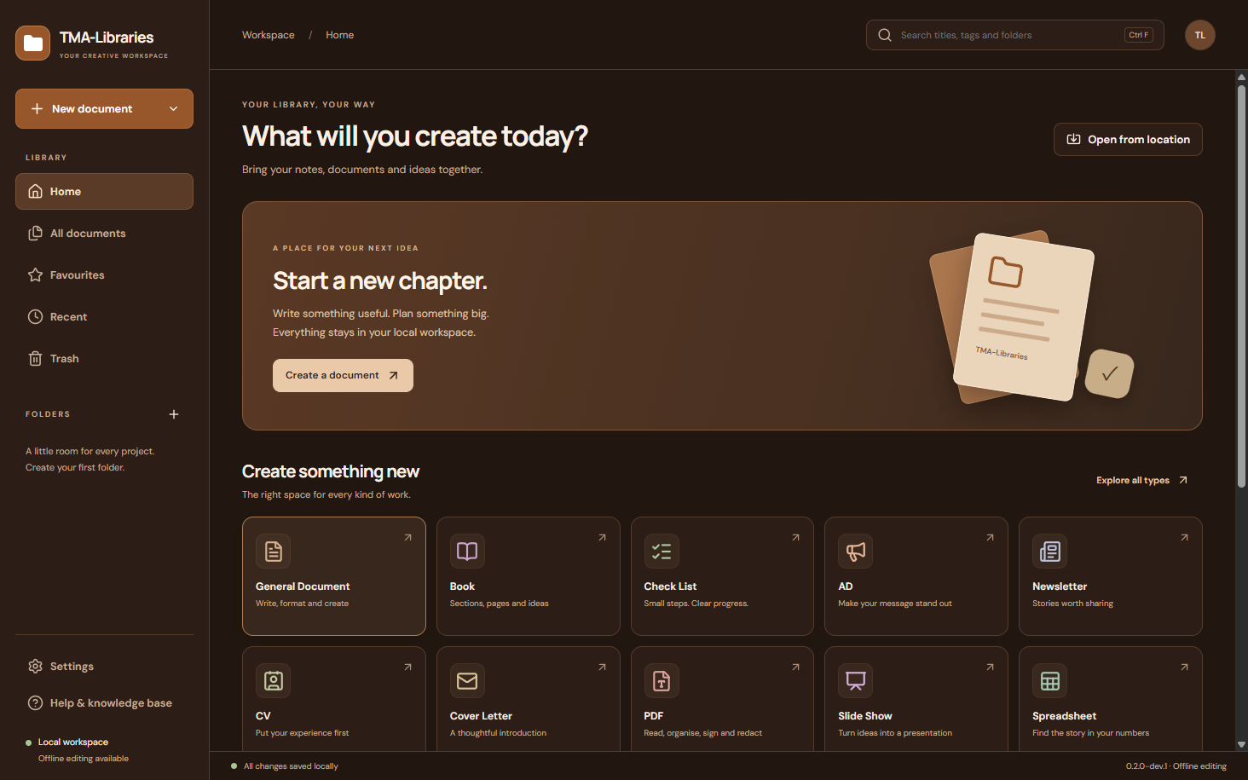
Libraries 0.2.0 development preview after verified launcher installation.

Launcher KB15 Spotify playback and browser streaming
Back to index
Open Spotify in navigation, or Spotify playback modes and account in Settings. Connect Spotify signs in through your browser using PKCE. Choose Spotify app / Connect device or Browser streaming with in-app controls.
In browser mode, open the web player, sign in there and start a track. Audio streams in the browser; TMA controls the active Spotify device. Premium and developer-app user access are required.
Each app authorizes separately. Finish one sign-in before starting another. The registered callback is http://127.0.0.1:43823/spotify/callback.
Authorization stays encrypted locally; without a secure Linux keyring it stays in memory. Closing the music window stops its 15-second refresh. Disconnect removes local authorization; revoke provider access in Spotify if needed.
A busy port, denied access, inactive device or rate limit has an actionable message. See Launcher‑KB6 and Launcher‑KB10 . Companion-app Spotify changes are uploaded as source for their next releases; existing companion downloads are unchanged.
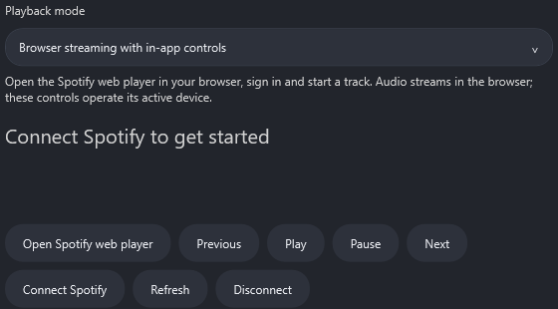
Spotify offers Connect controls and browser streaming with in-app controls. Sign-in is optional.

Launcher KB16 Autofill profiles across TMA apps
Back to index
Save your optional name and email addresses through the top-right profile icon. Autofill compatible TMA app profiles on this device enables shared suggestions; Mail and social metadata keep their additional sharing controls. Compatible apps read suggestions when opened or focused.
Empty fields and previously imported values update automatically; app-specific edits and connected account identities are preserved. Office and Finance source updates add editable profile icons; their public downloads gain this with their next releases. Mail already supports launcher name/email suggestions on Windows.
Profile sharing is local to the current OS user, not cloud sync or provider authentication. Disabling sharing stops future imports and keeps existing local app values. Credentials and app-specific keys are still entered in each provider app.
See Launcher‑KB3 , Launcher‑KB4 and Launcher‑KB10 . Earlier released Mail versions continue their existing display-name sync behavior until the companion update; connected email identities stay protected.
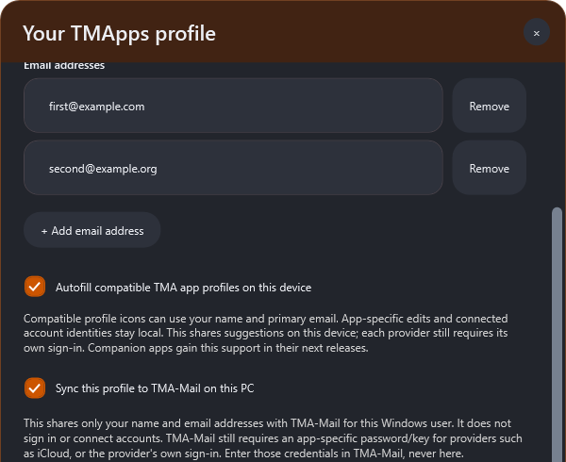
The launcher profile enables local autofill for compatible TMA app profile icons.

Launcher KB17 Check service status
Back to index
Open Service Status and choose Check APIs now. API Checkers group the suite public service checks by app. Gray means not checked.
Glowing green means the public endpoint responded; glowing red means unavailable from this device or rate-limited. Checks send no account credentials and do not run in the background. Green is not proof that an account is signed in, a subscription is active or permissions are granted.
Microsoft and Google sign-in discovery and GitHub and Spotify endpoint reachability are covered; additional app-specific providers and IMAP/SMTP account tests remain inside their apps. Companion Spotify integration reaches downloads in their own releases. Retry after checking your connection if a service is red.
See Launcher‑KB7 , Launcher‑KB8 and Launcher‑KB15 .
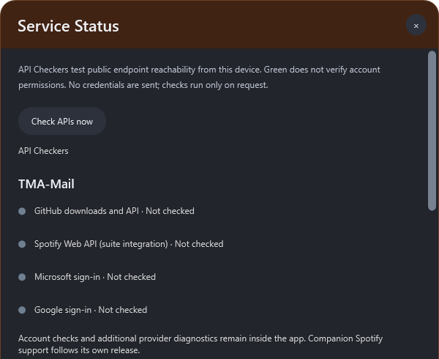
Service Status checks public service reachability only when requested.

